**WEBSTEDER PLATFORM**

**Introduction**

E-commerce is fast gaining ground as an accepted and used business paradigm. More and more business houses are implementing web sites providing functionality for performing commercial transactions over the web. It is reasonable to say that the process of shopping on the web is becoming commonplace. The objective of this project is to develop a general purpose e-commerce store where product like HtmL&&Css templates can be bought from the comfort of home through the Internet. However, for implementation purposes, this paper will deal with an online shopping for websites hosts. An online store is a virtual store on the Internet where customers can browse the catalog and select products of interest. The selected items may be collected in a shopping cart. At checkout time, the items in the shopping cart will be presented as an order. At that time, more information will be needed to complete the transaction. Usually, the customer will be asked to fill enter a Email address, a some personal info and payment information such as credit card number. An e-mail notification is sent to the customer as soon as the order is placed, the seller will be asked to fill enter a project info, a some personal info, project demo and website description. An e-mail notification is sent to the admin as soon as the order is placed and the admin will show the project info on website and if there is any order for that project the admin will contact with buyer and seller.

**Description**

**Websteder is website for buy and sell websites host and Html&Css templates**

* Any member can register and view available products.
* Only registered member can purchase products.
* Sell products page is available to sell web products.
* There are three roles available: Visitor, User and Admin.
  + Visitor can view available products.
  + User can view and purchase products.
  + An Admin has some extra privilege including all privilege of visitor and user.
* Admin can add products, edit product information and add/remove product.
* Admin can add user, edit user information and can remove user.
* Admin can deliver order to user based on order placed by sending mail.

Website Pages:

Client side:

* Home Page
* About us Page
* Products Page
* Cart Page
* Checkout Page
* Login Page
* Register Page
* Sell products page

Admin side:

* Category/Add category
* Products/Add products
* Orders
* Reviews
* Coupons
* Users

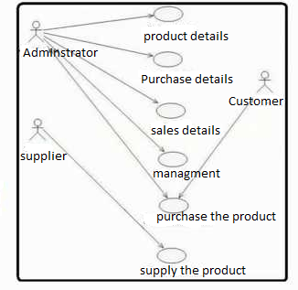

Main Features:

* Usability
* Security
* Responsive design
* Maintainability
* A product search form
* Shopping cart
* Show demo
* Related products

Used Languages,Libraries and Tools:

* HTML and CSS
* PHP
* Laravel Framework
* Bootstrap
* MySQL
* File upload manager library
* TinyMCE library
* Visual Studio Environment

Test Information:

* User account:  
  email: user@gmail.com  
  password: 1111
* Admin account:  
  email: admin@gmail.com  
  password: 1111

Links:

* Trello:   
  [Master_Piece_Project | Trello](https://trello.com/b/WZOBC1wG/masterpieceproject)
* WireFrame:

<https://app.moqups.com/fpCX6FBkehyObUl2whodw70JKFQHlXZ4/view>

* GitHub Link:  
    
  https://github.com/ahmadrl/masterPiece